Jenkins Task-2

1 Configure 2 slave machines in the Jenkins master.
Launch 3 Instance
1. Jenkins-Master
2. slave-01
3. slave-0
>>Slave-01
Install Java in Salve-01
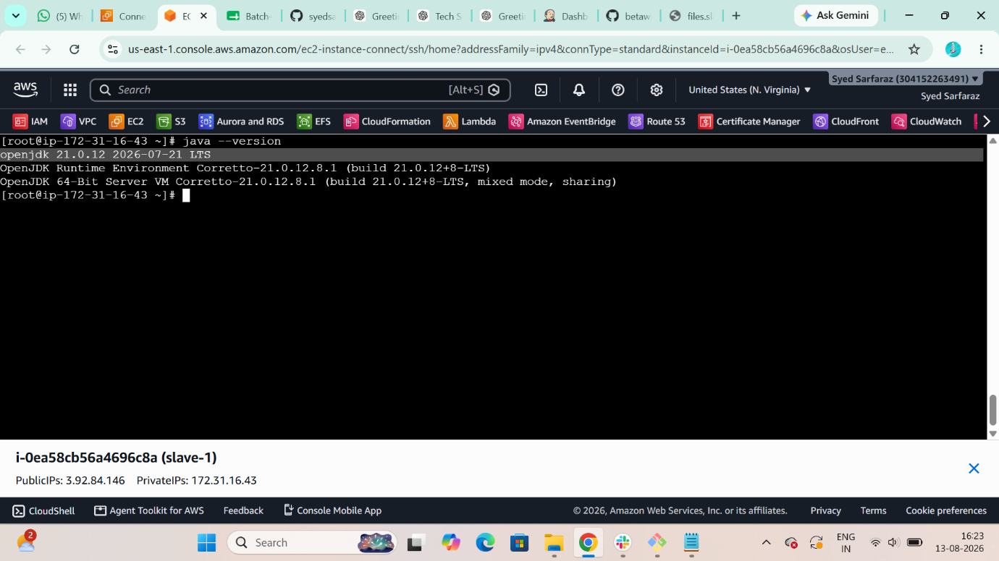
Create $ ssh-keygen
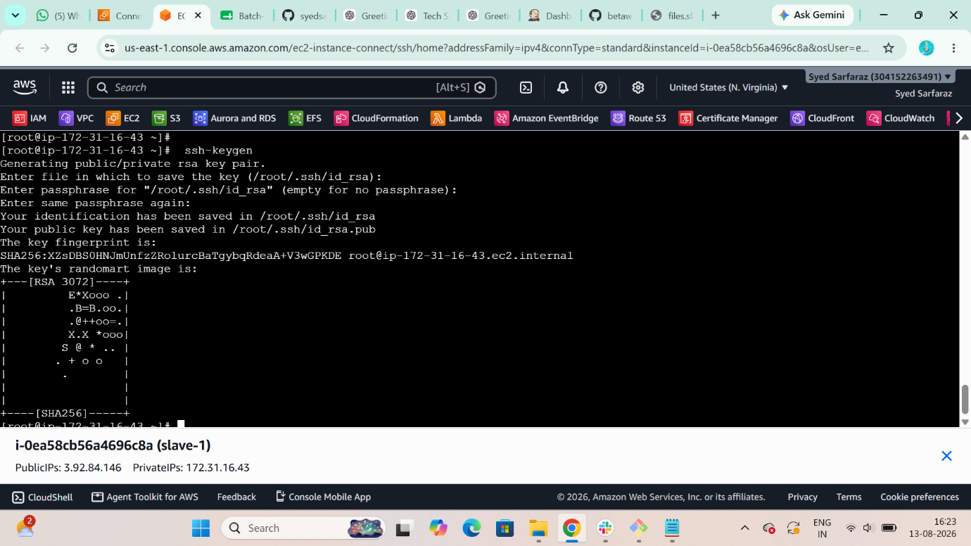
Switch user $ sudo su –
See hidden files $ ls -la
Change directory $ cd .ssh
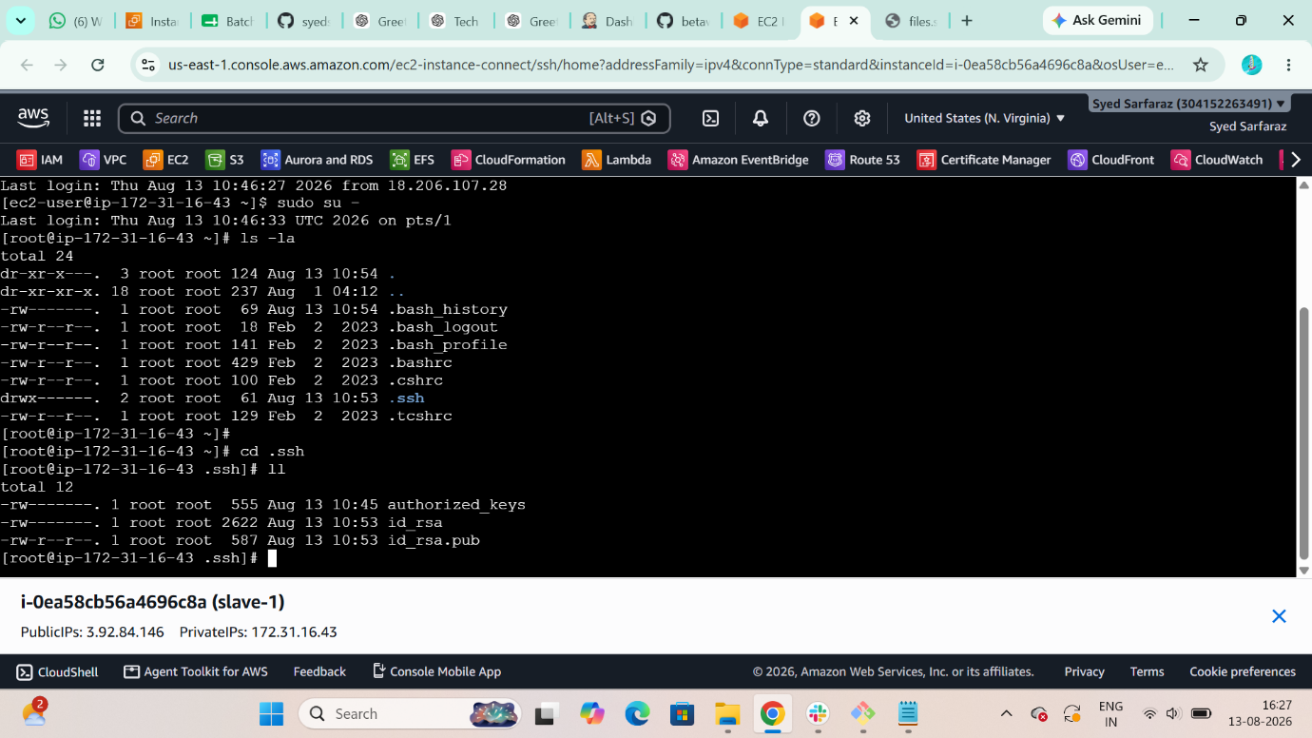
Migrate you public .pem file into Authorized_key
$ cat is_rsa.pub > authorized_keys
$ cat authorized_keys
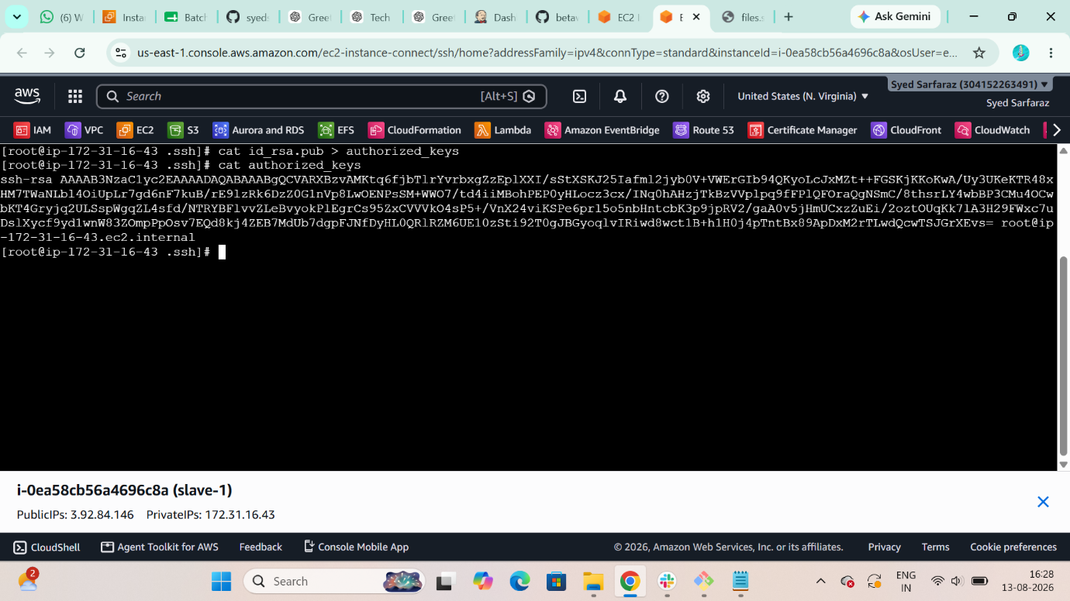

Grant permission to authorized_keys file
$ chmod 700 authorized_keys
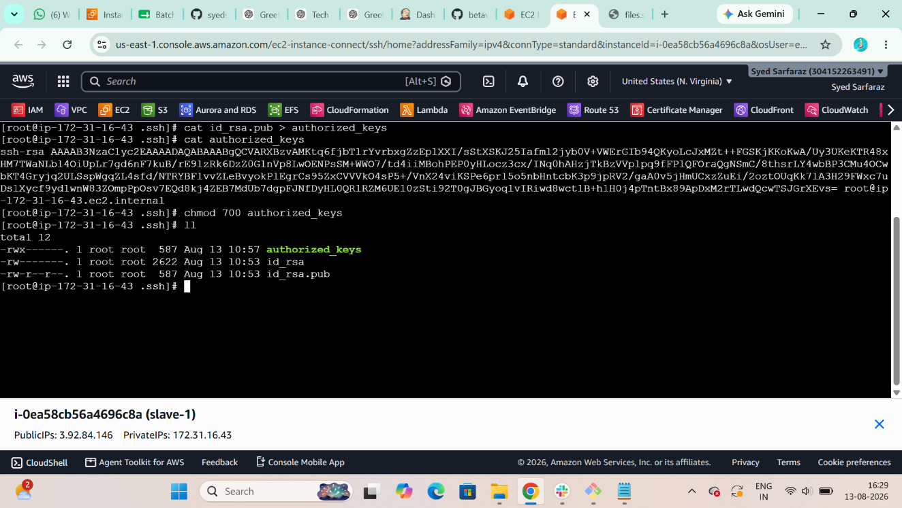

>>Jenkins-Master
$ ssh -i jenkins.pem ec2-user@54.91.11.113
switch to root user: $ sudo su –
$ sudo wget -O /etc/yum.repos.d/jenkins.repo \
https://pkg.jenkins.io/rpm-stable/jenkins.repo
$ sudo dnf upgrade
$ sudo dnf install fontconfig java-21-openjdk
$ sudo dnf install jenkins
$ sudo systemctl daemon-reload
$ yum install git -y
cd /var/lib/jenkins workspace/
ls
first-job 'git job-1' 'git job-2' second-job
cd /var/lib/Jenkins

$ mkdir .ssh
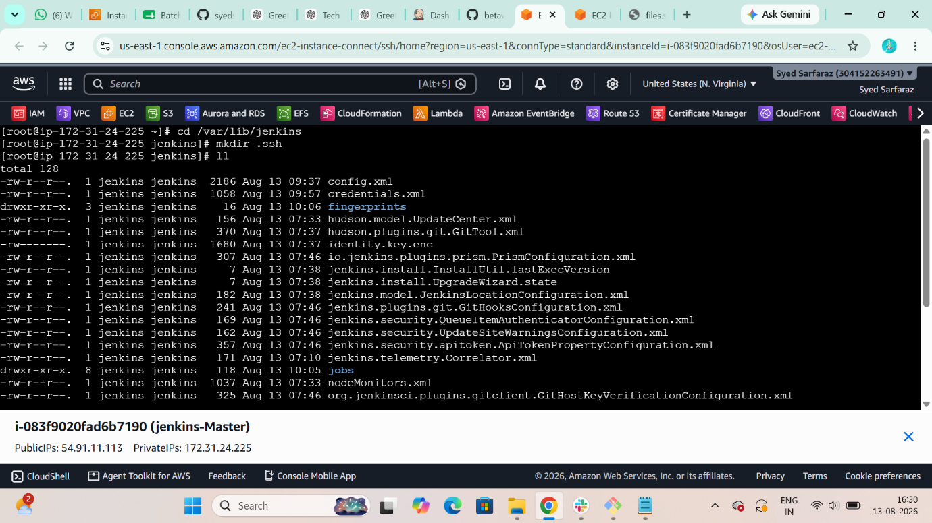
$ ls -la
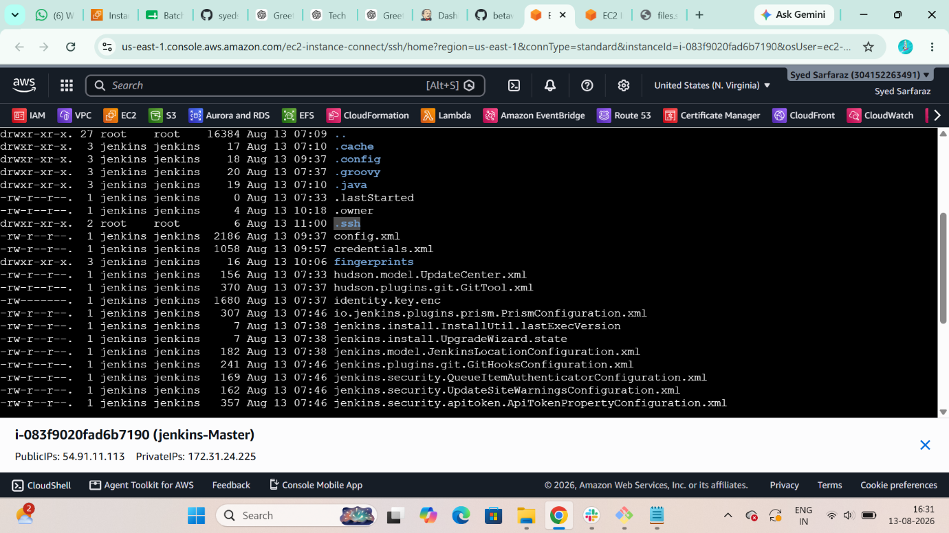
[root@ip-172-31-24-225 jenkins]# run this in Jenkins:
$ ssh-keyscan -H 3.92.84.146 >>/var/lib/jenkins/.ssh/known_hosts
$ ls -la
$ chmod 700 known_hosts

[root@ip-172-31-24-225 jenkins]#
$ ssh-keyscan -H 100.61.153.0 >> /var/lib/jenkins/.ssh/known_hosts
[root@ip-172-31-24-225 .ssh]# cat known_hosts
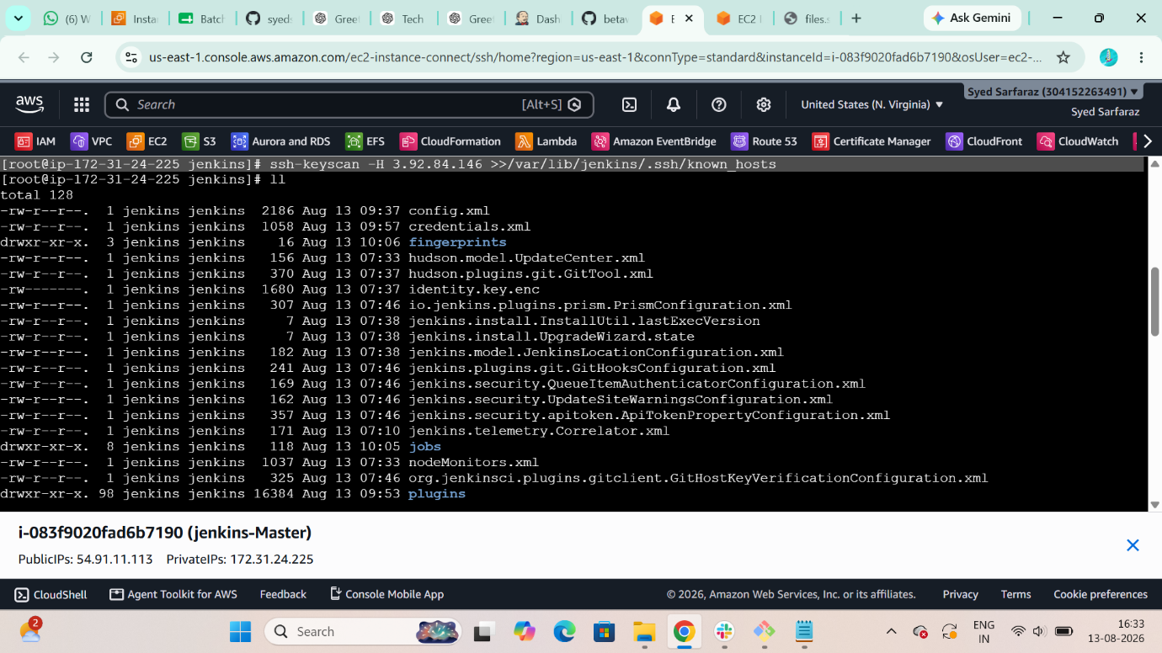
$ cat know_hosts
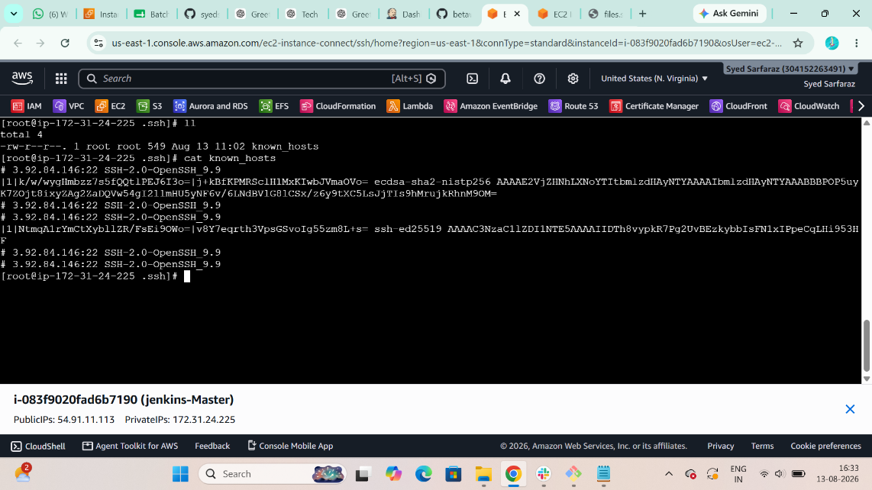
$ pwd
$ chmod Jenkins:Jenkins Known_hosts
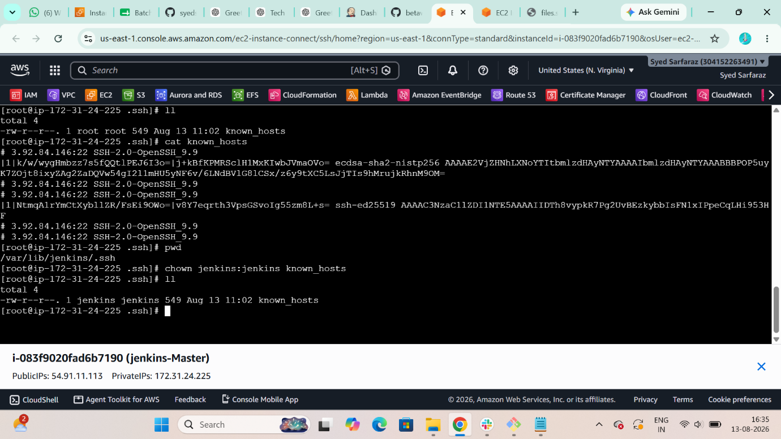

Create a node for slave-01
Jenkins > manage Jenkins > node > new node > node name
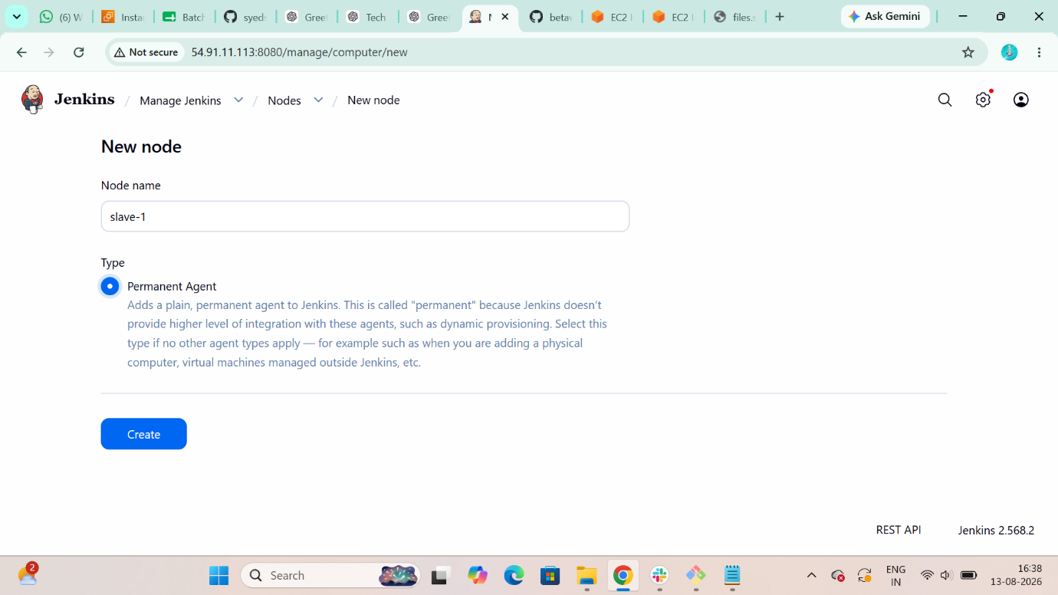
Add Remote root directory path
/home/ec-user/
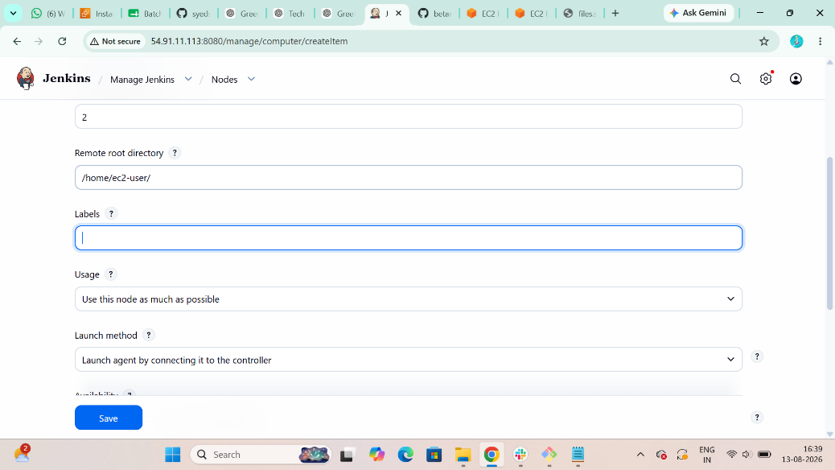
Add Credentials : ssh username with private key
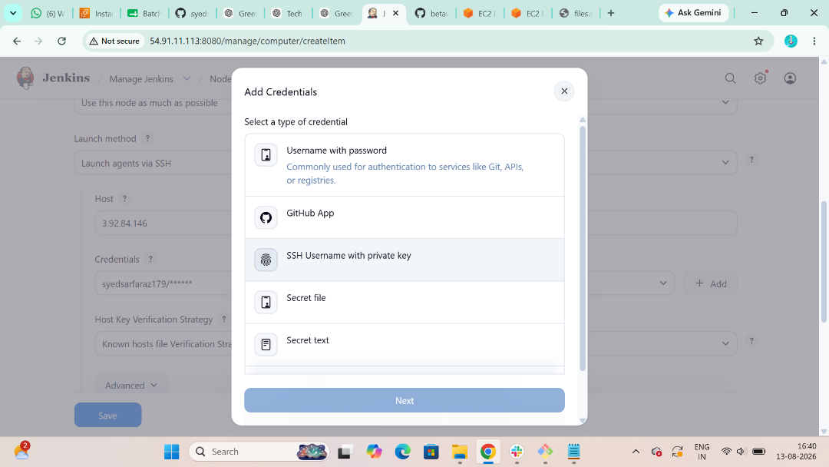

Add your .pem key and save it
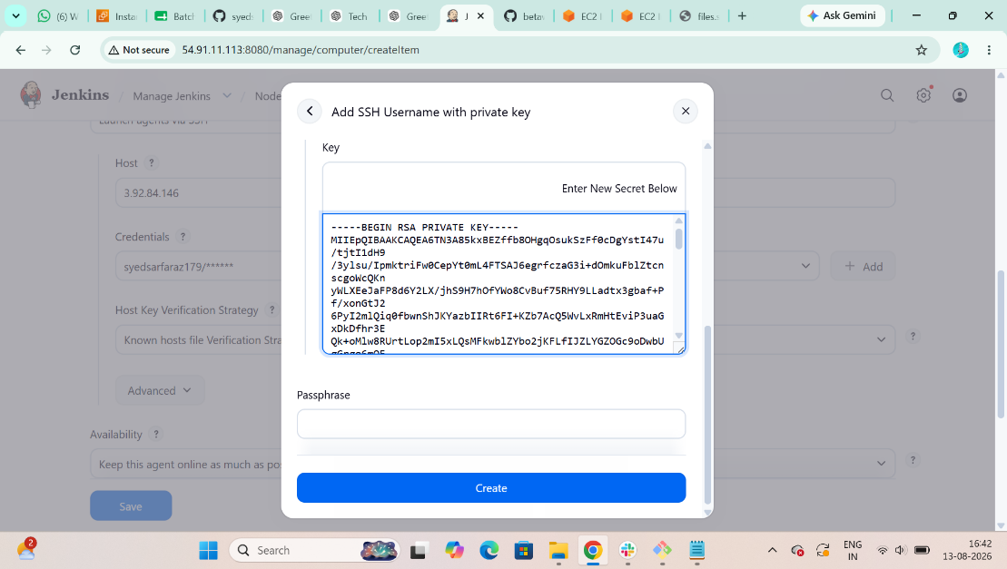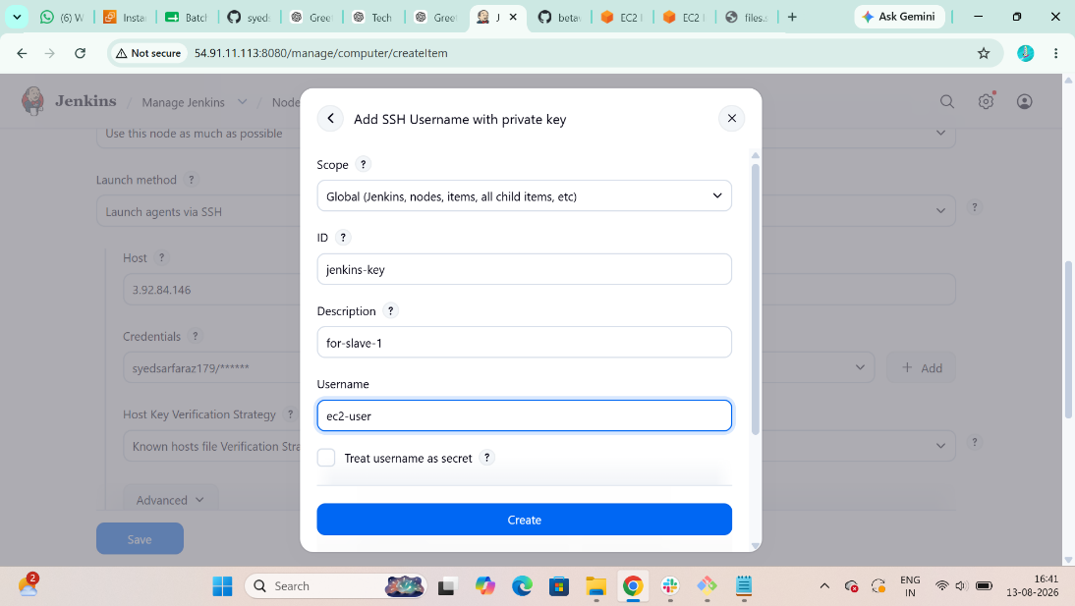
Then select you .pem file
Add your slave machine ip address in host section
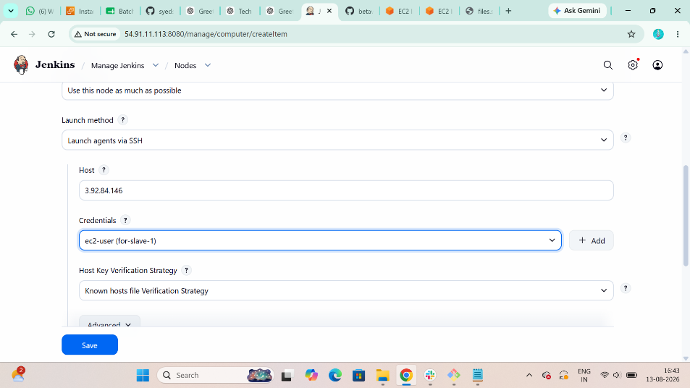
Now your 1st node is successfully added
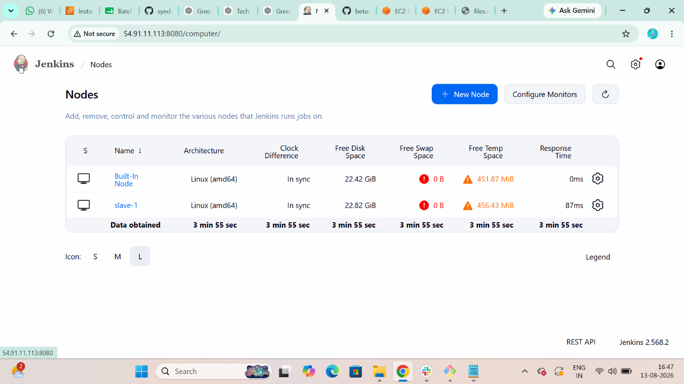

>>Slave-02
- Install Java in Salve-02 $ yum install java-21-amazon-corretto -y
- Create $ ssh-keygen
- Switch user $ sudo su –
- See hidden files $ ls -la
- Change directory $ cd .ssh
- Migrate you public .pem file into Authorized_key
- $ cat is_rsa.pub > authorized_keys
- $ chmod 700 authorized_keys
- $ cat authorized_keys
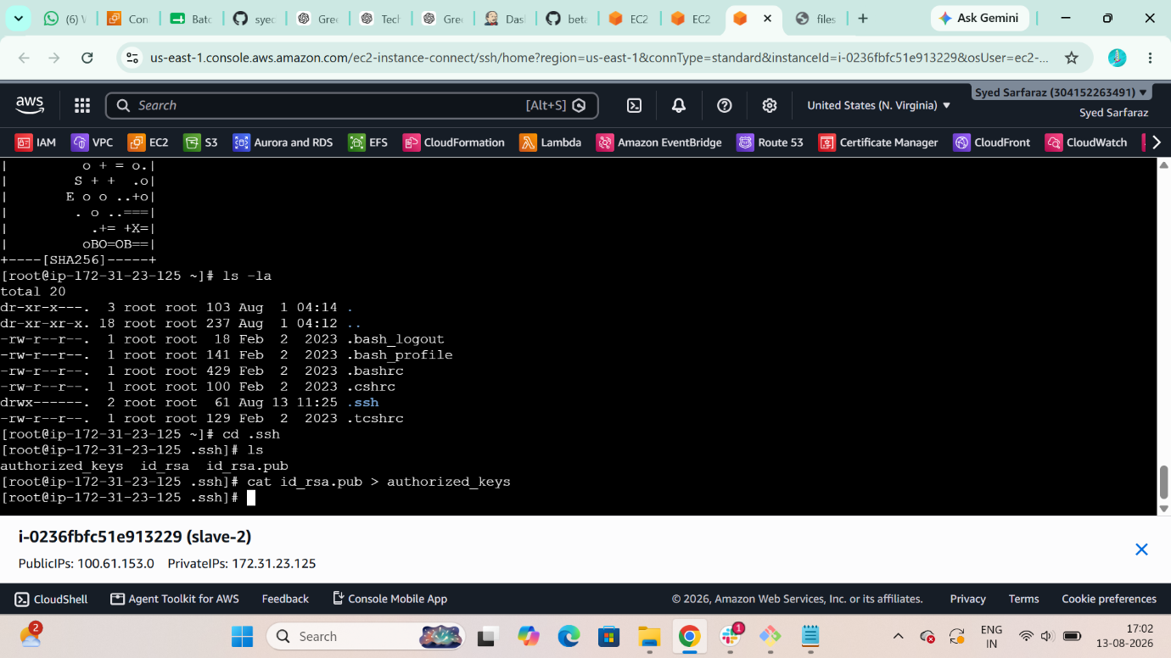
Verified it in master machine
$ cat known_hosts
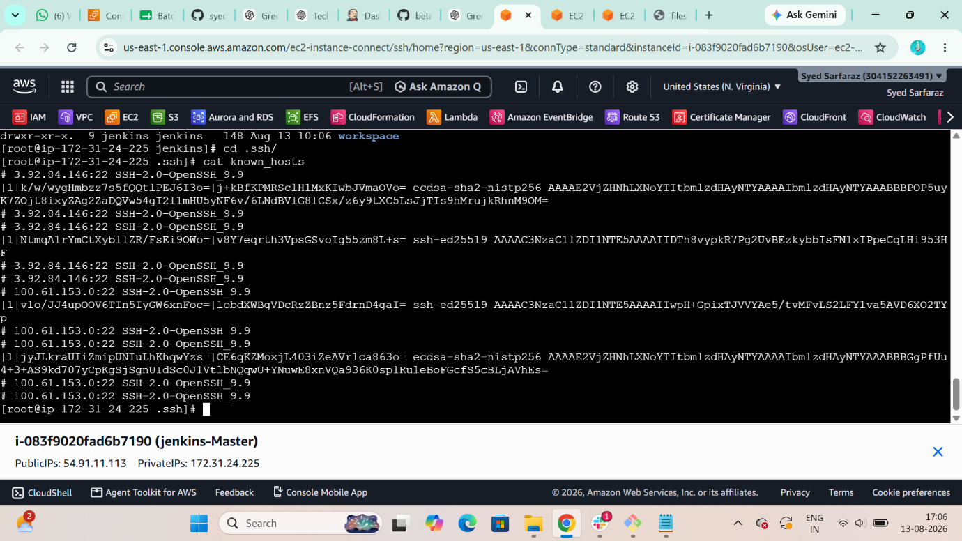

- Create a node for slave-02
Jenkins > manage Jenkins > node > new node > node name
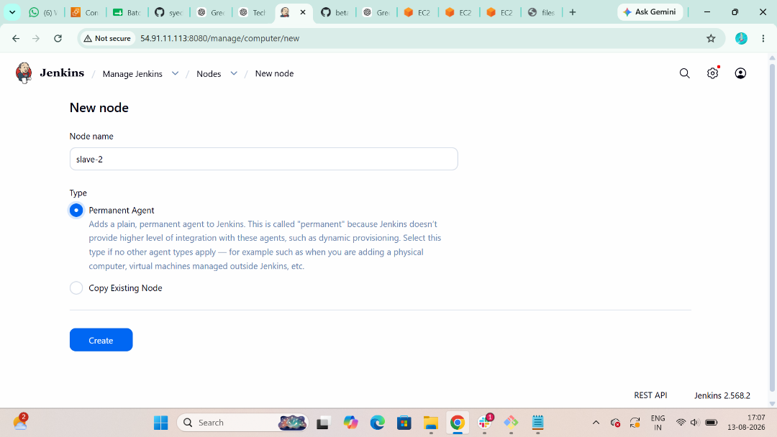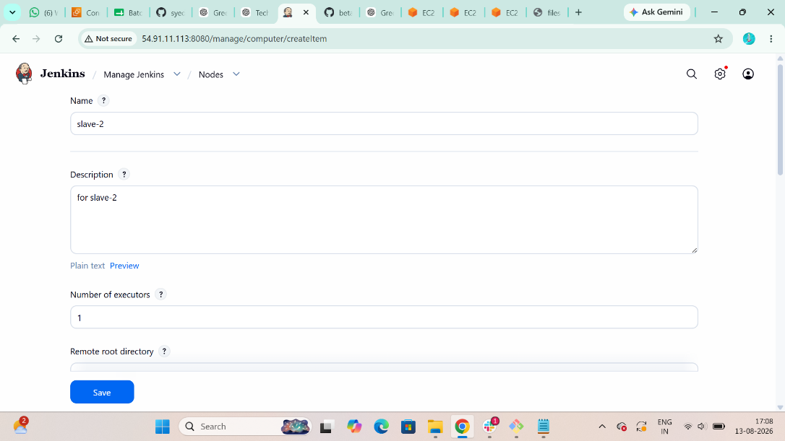
- Add Remote root directory path
/home/ec-user/
- Add your slave machine ip address in host section
- Add Credentials : ssh username with private key


- Add your .pem key and save it

- Then select you .pem file
- This is an error of threshold disk space
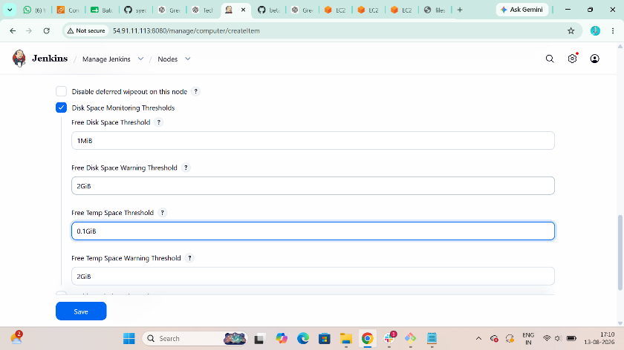
Now Build it
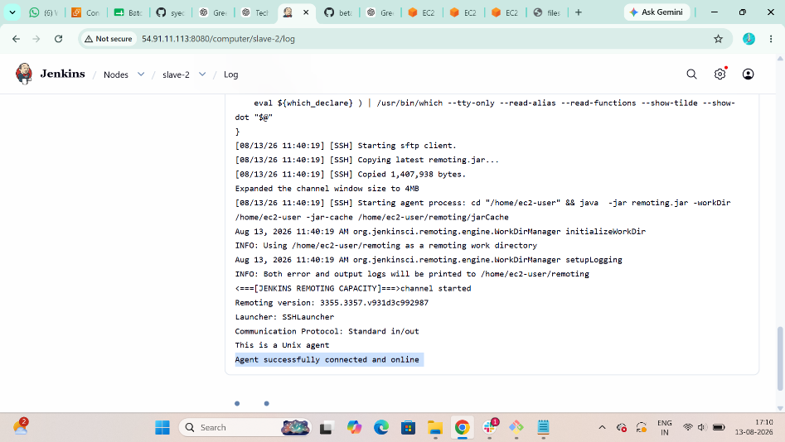

Now your 2nd node is successfully added
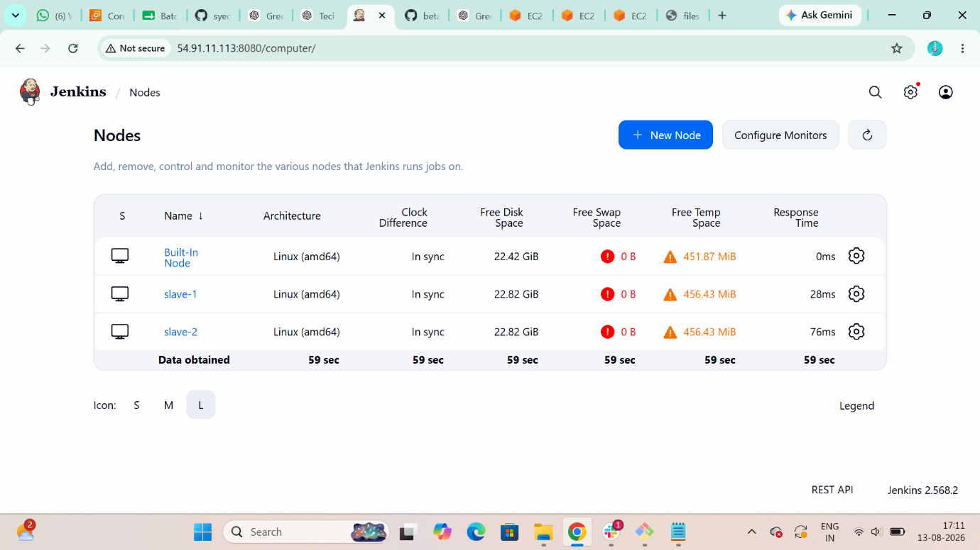

2. Configure webhooks to the Jenkins job
Step 1: First copy github <url>
Step 2: create webhook
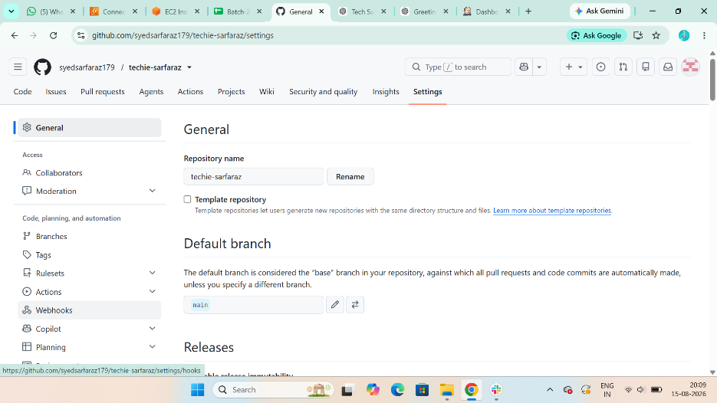

Github > settings > webhook > create webhook >
Payload URL : http://ip-of-jenkins:8080/github-webhook/
Content type : application/json
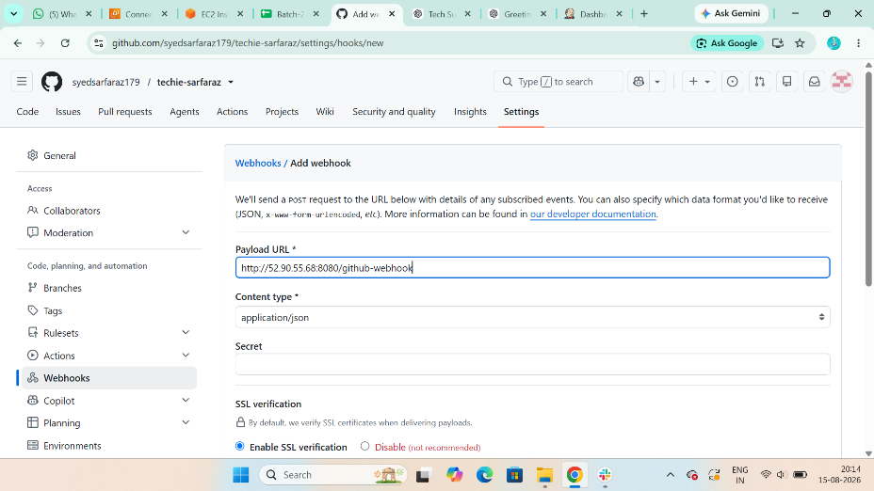
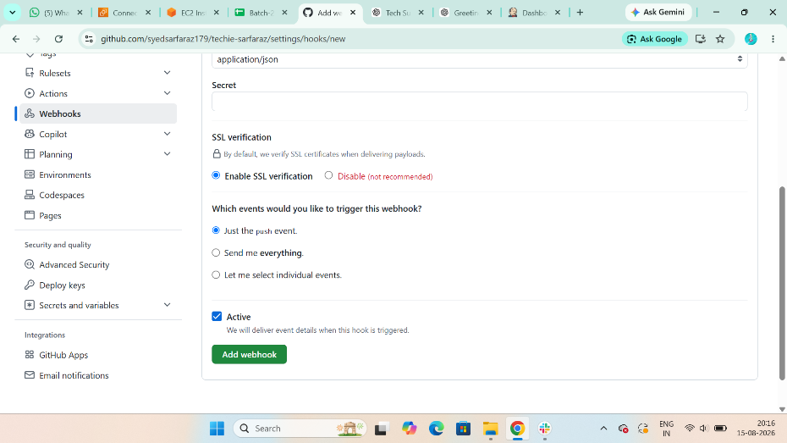

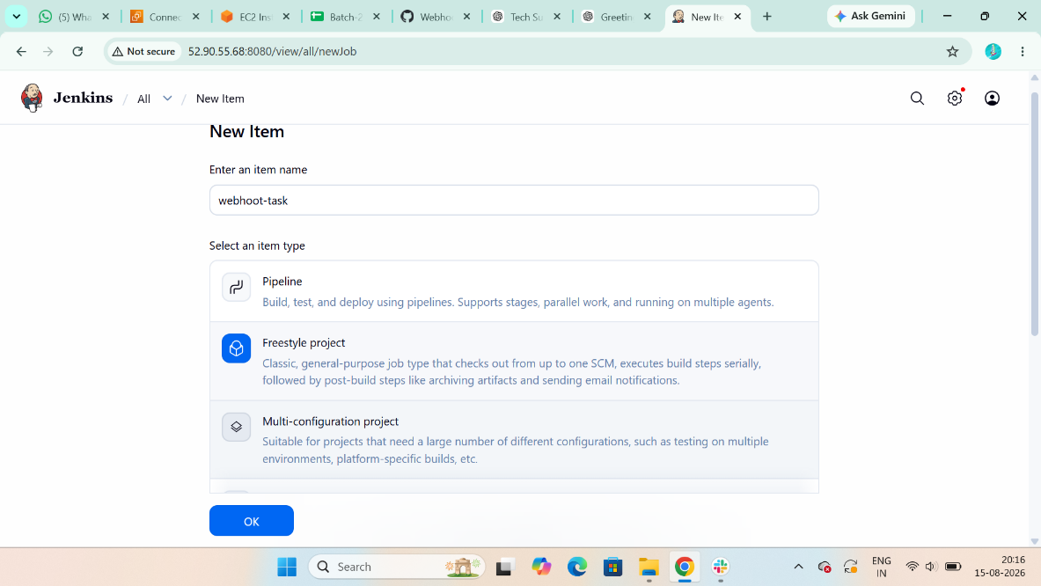
Setp 3 : Go to Jenkins Gui > New iteam > create job > Source Code Management >
Github <url> step 1 link
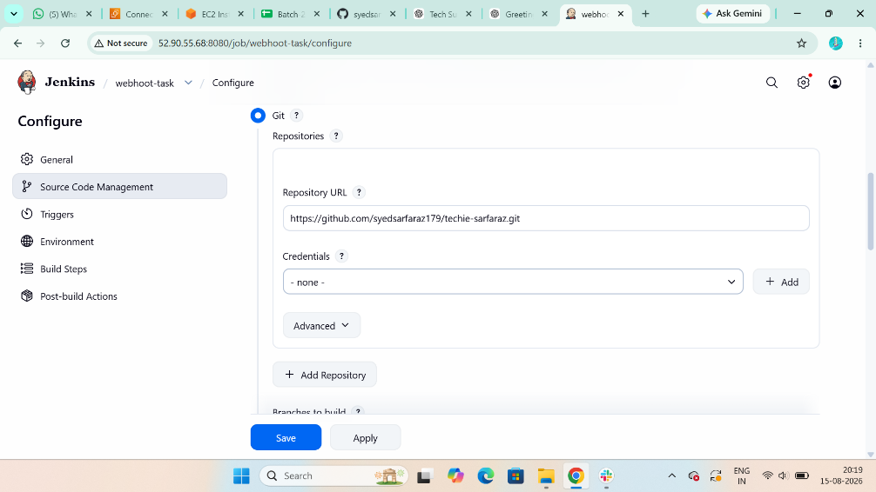

Step 4 : Triggers > GitHub hook trigger for GITScm polling
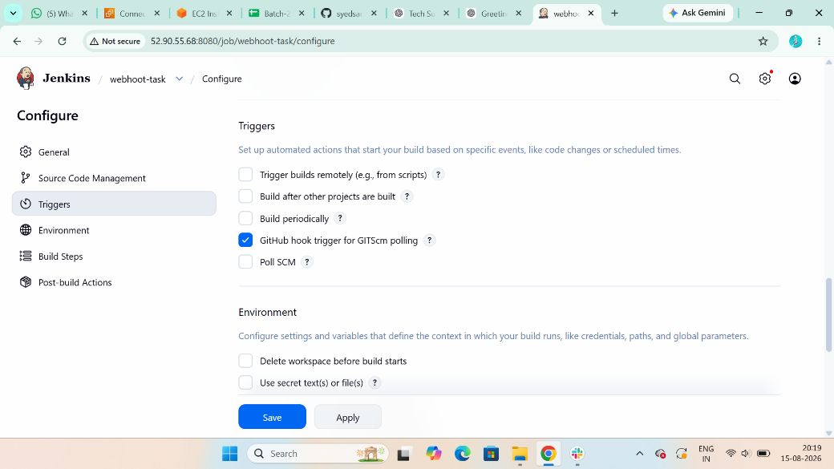

Note: Add Plugin’s: 1) Git Plugin 2) Credentials
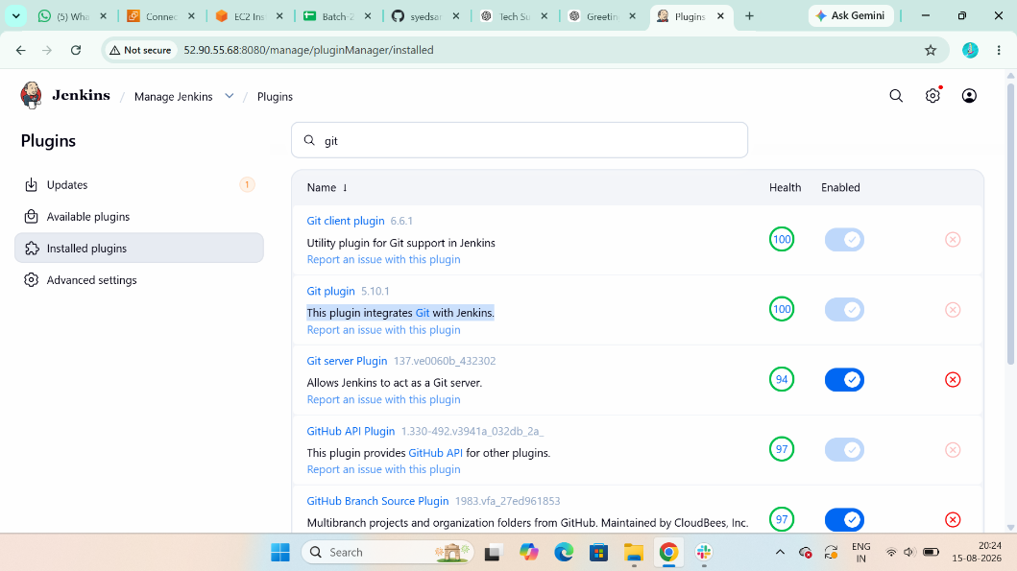

Step 5: Go to Security > Authorization > Any one can do anything
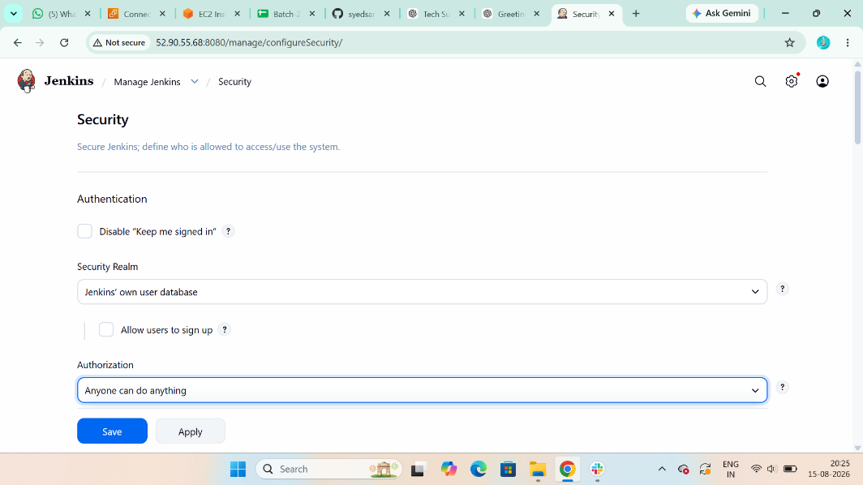
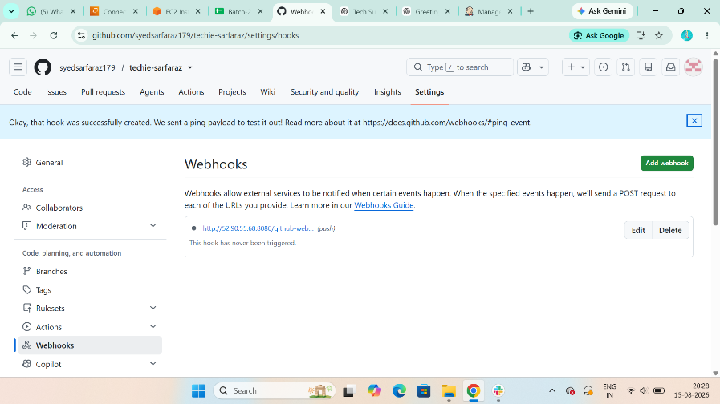
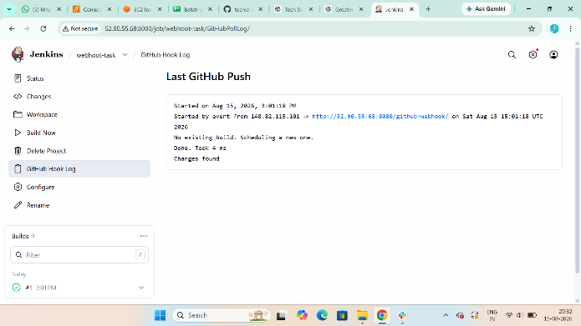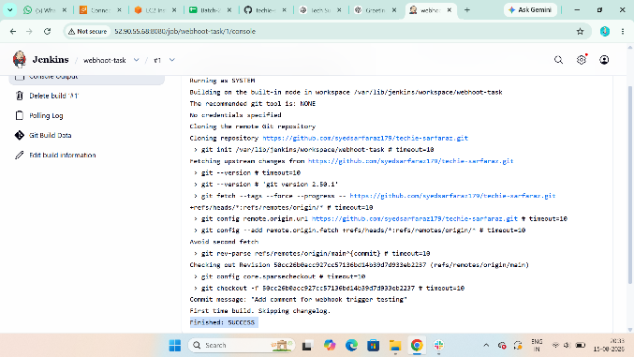

3. Configure Poll SCM and Build Periodically options in the Jenkins job.
Poll SCM: It trigger only when the code is change.
Step 1: First copy github <url>
Setp 2 : Go to Jenkins Gui > New iteam > create job > Source Code Management >
Github <url> step 1 link
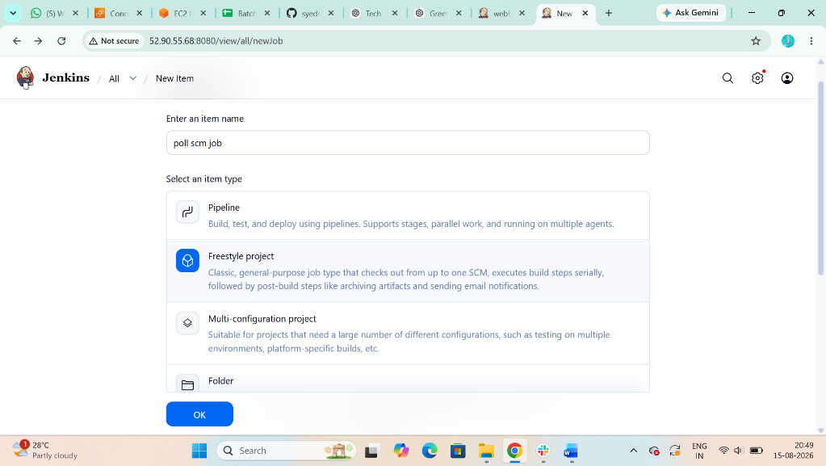
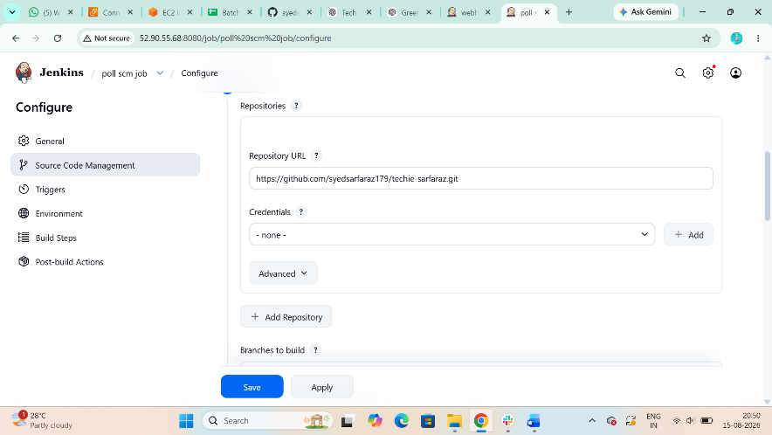

Step 3 : Triggers > Poll Scm > Schedule > ex (H/2 * * * *)
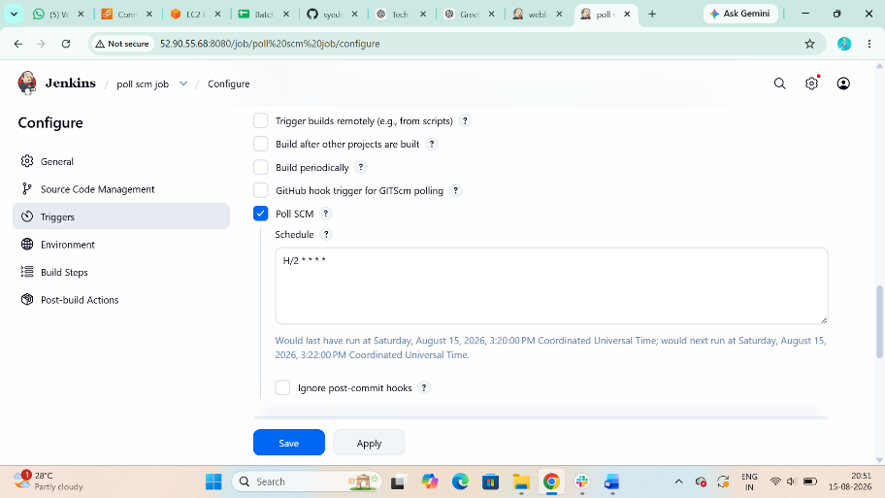
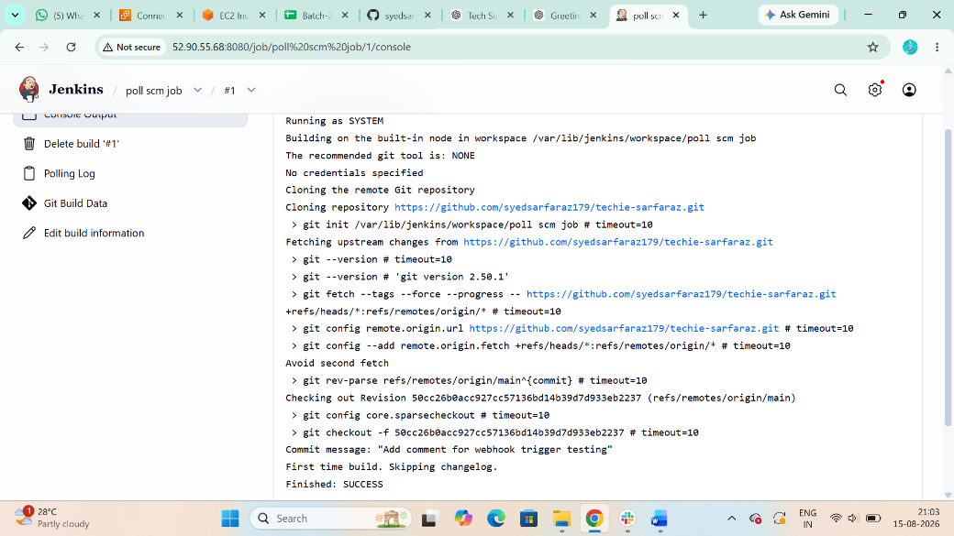

Build Periodically: whether code is change or not It will trigger
Step 4: First copy github <url>
Setp 5 : Go to Jenkins Gui > New iteam > create job > Source Code Management >
Github <url> step 1 link
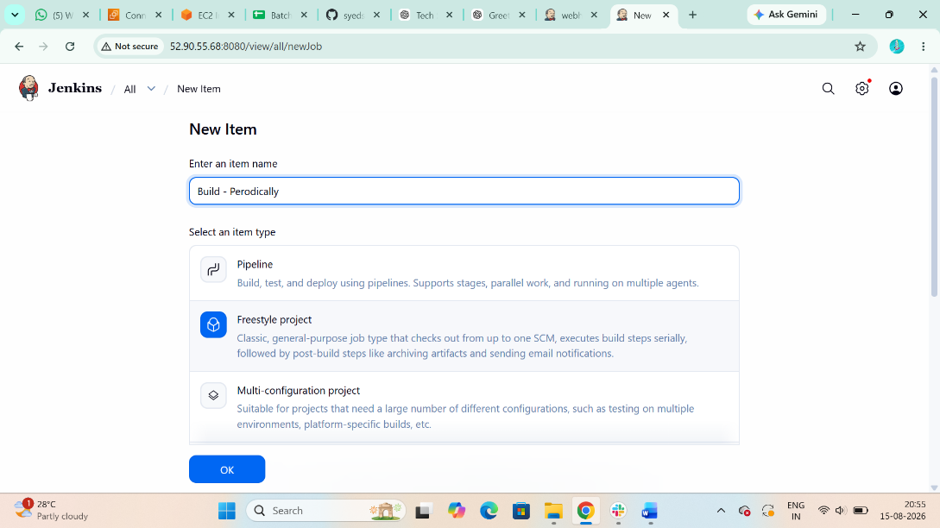
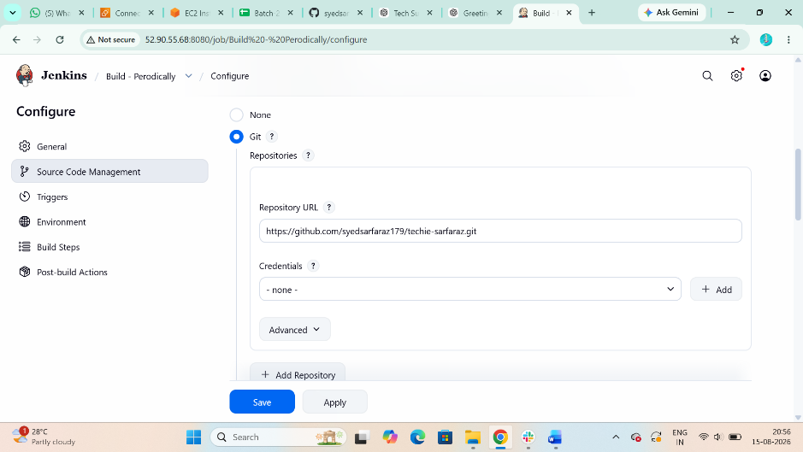

Step 6 : Triggers > Build Periodically > Schedule > ex (H/2 * * * *)
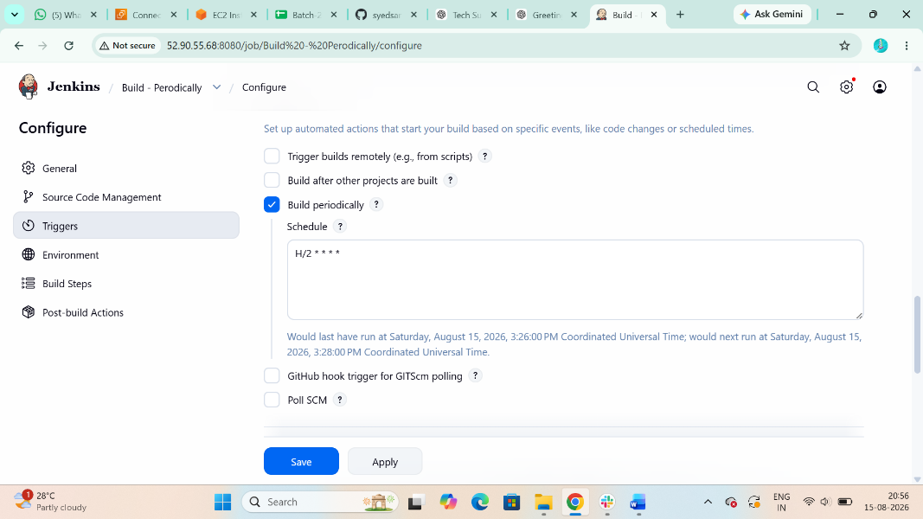
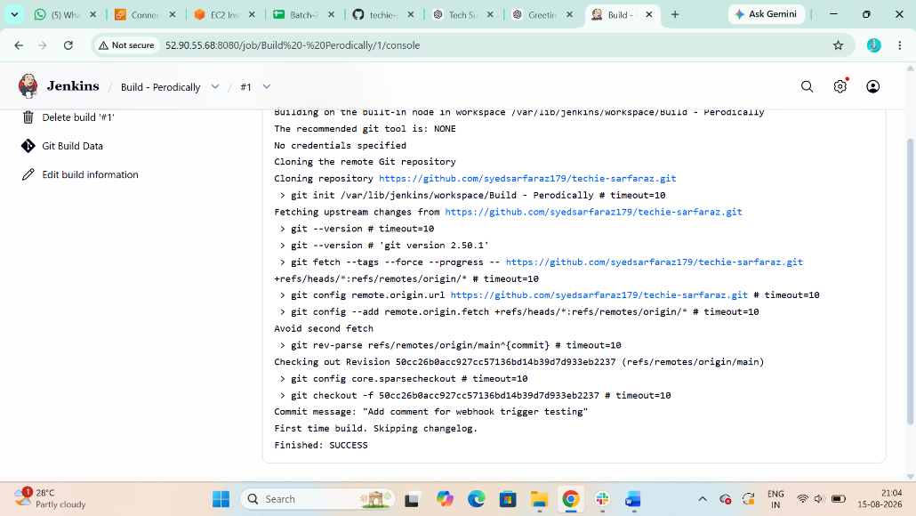

4. Take a backup of the Jenkins server using abash-script.
Backup Jenkins Using Bash Script
The most important Jenkins data is normally under:

Step 1: sudo ls -lah /var/lib/jenkins
You can create a compressed backup using tar.
Create backup directory
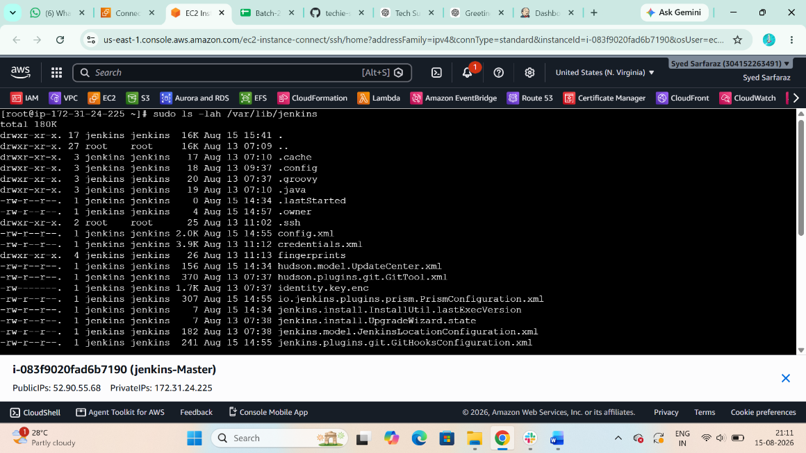

Step 2 : sudo mkdir -p /backup/jenkins
Bash backup script
Create:

Step 3: sudo vi /usr/local/bin/jenkins-backup.sh
Bash script
Add:
#!/bin/bash
DATE=$(date +"%Y-%m-%d_%H-%M-%S")
BACKUP_DIR="/backup/jenkins"
JENKINS_HOME="/var/lib/jenkins"
mkdir -p "$BACKUP_DIR"
tar -czf "$BACKUP_DIR/jenkins_backup_$DATE.tar.gz" \
-C "$JENKINS_HOME" .
echo "Jenkins backup completed:"
echo "$BACKUP_DIR/jenkins_backup_$DATE.tar.gz"
Save it.
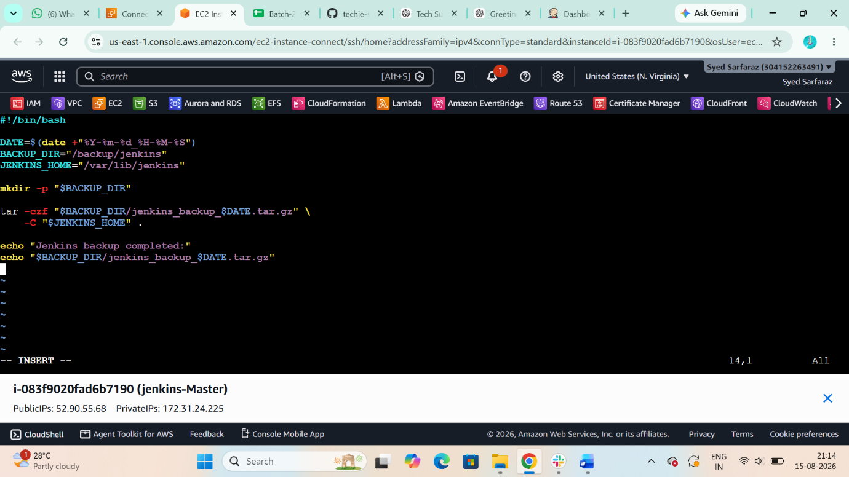

Step 4 : Give execute permission:
sudo chmod +x /usr/local/bin/jenkins-backup.sh
step 5: $ cd /usr/local/bin/
step 6: ./jenkins-backup.sh (bash script)
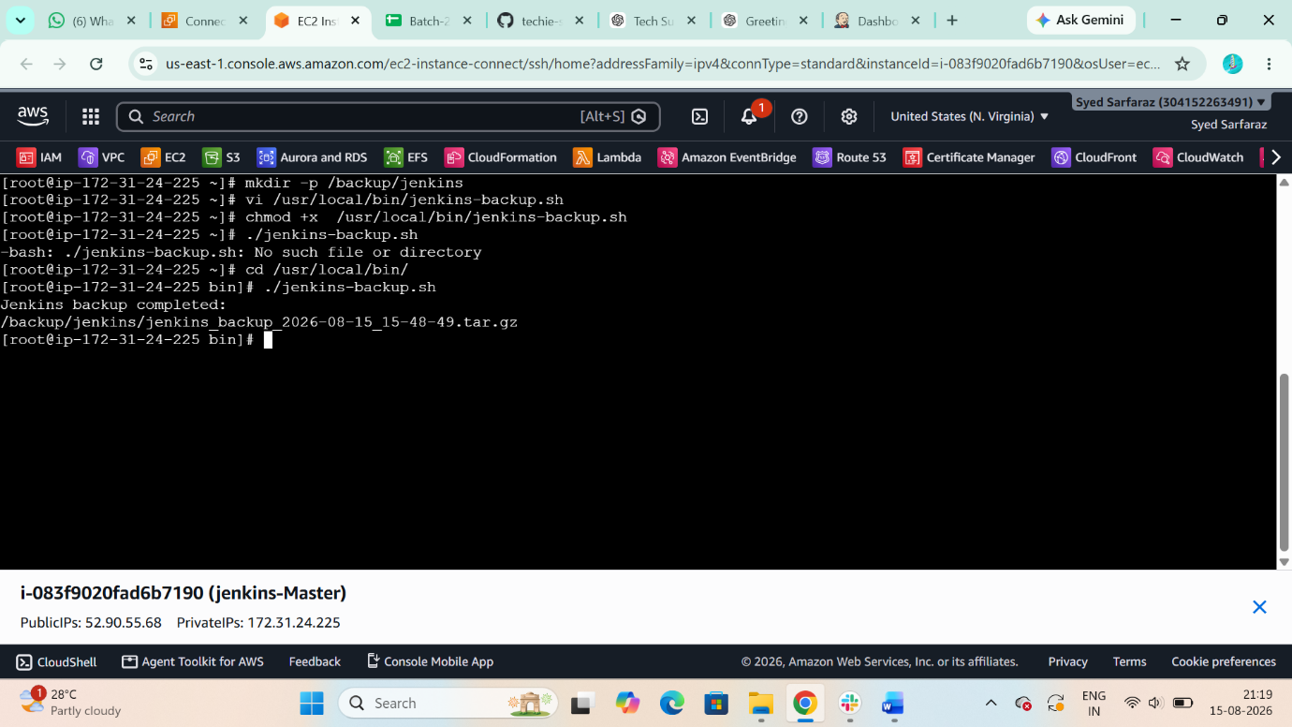
Now the back up is created successfully
Conformation and verification
sudo ls -lh /backup/jenkins
You should see something like:
jenkins_backup_2026-08-12_15-30-00.tar.gz
6. What Does the Jenkins Backup Contain?
The important directory is:
/var/lib/jenkins
It contains things such as:
/var/lib/jenkins/
│
├── config.xml
├── jobs/
├── plugins/
├── users/
├── secrets/
├── credentials.xml
├── nodes/
├── workspace/
├── fingerprints/
└── ...

5. Take a backup of Jenkins using theThinBackupplugin.
Now perform the same backup using the Jenkins ThinBackup plugin.
Go to:
step 1: Manage Jenkins → Plugins >Add ThinBackup
After installation:
step 2: Manage Jenkins → ThinBackup > click back now
ThinBackup creates the backup in the configured directory.
Check from Linux:
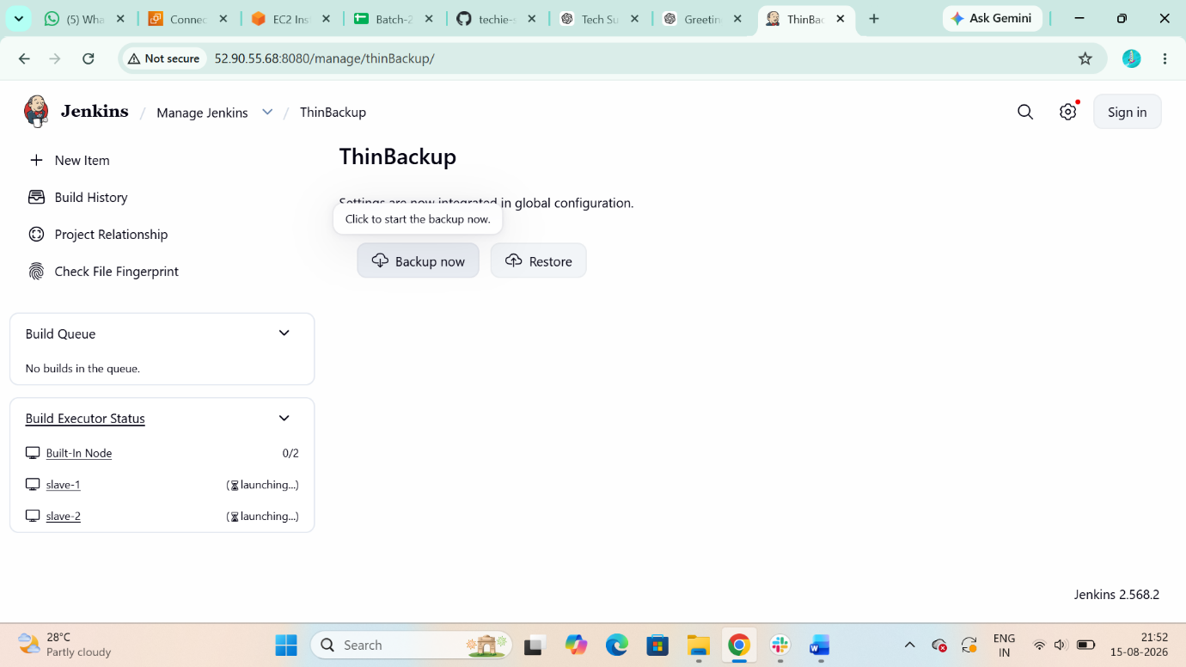

Manual method
step 3:
$ sudo ls -lah /backup/jenkins-thinbackup
jenkins]# mkdir -p /backup/jenkins-thinbackup
jenkins]# chown -R jenkins:jenkins /backup/jenkins-thinbackup/
jenkins]# ls -lah /backup/jenkins-thinbackup/
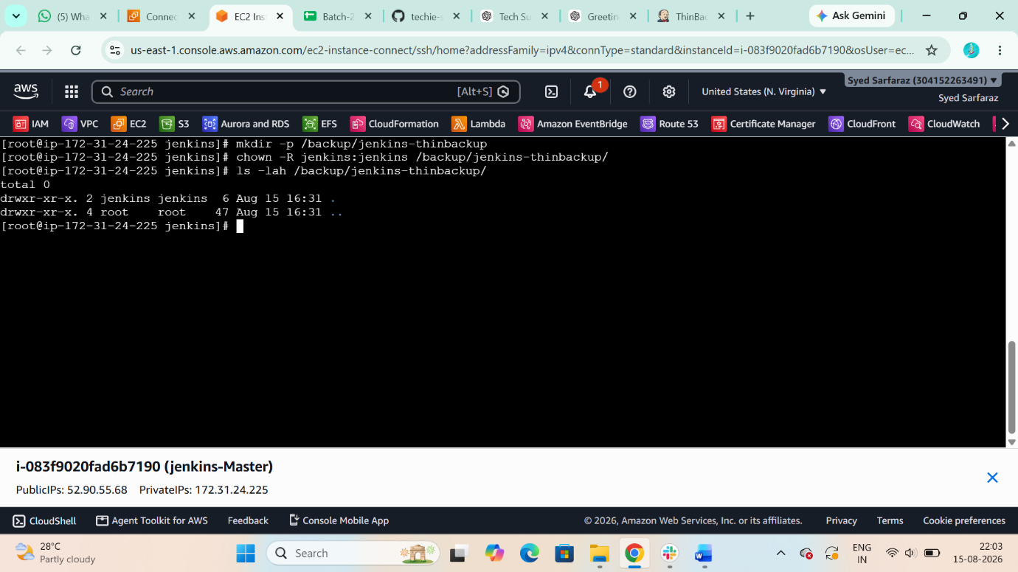

6. Set up a new Jenkins server and restore the backup taken in task 4.
* Install java
$ yum install java-21-amazon-corretto -y
* Download jenkins Repo:
$ sudo wget -O /etc/yum.repos.d/jenkins.repo https://pkg.jenkins.io/redhat-stable/jenkins.repo
$ sudo rpm --import https://pkg.jenkins.io/redhat-stable/jenkins.io-2023.key
* Update ec2:
$ sudo yum upgrade
* Install Jenkins:
sudo yum install Jenkins -y
systemctl start jenkins
systemctl enable Jenkins
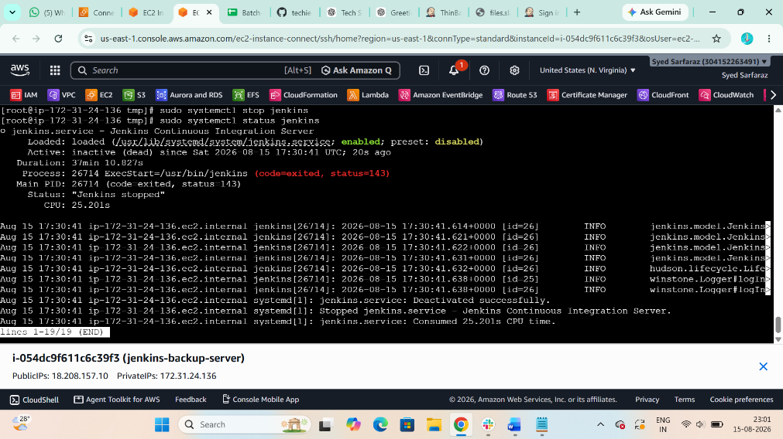

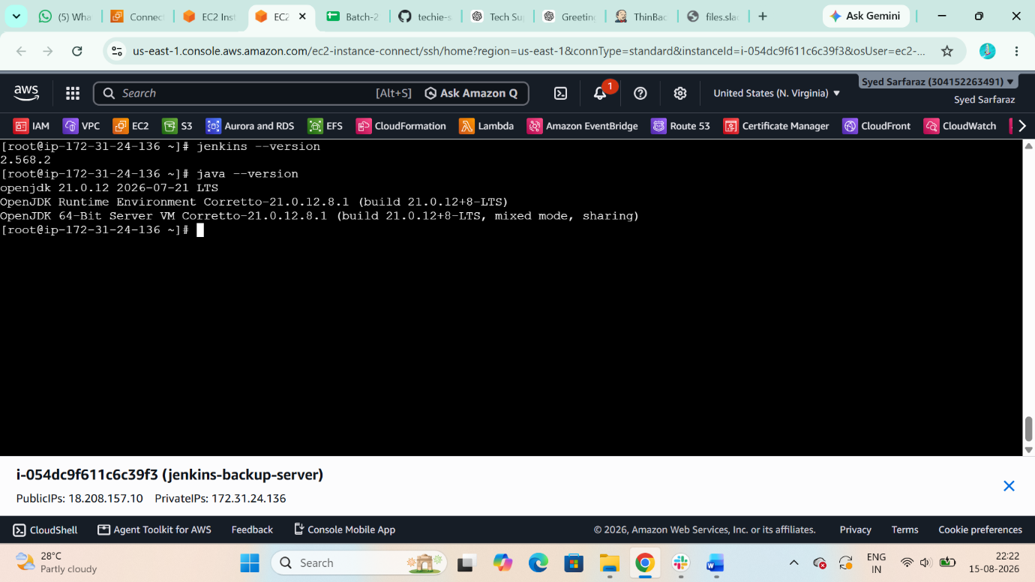
>>Import the jenkins .pem key from Your local machine with the help of gitbash
$ cat Jenkins.pem
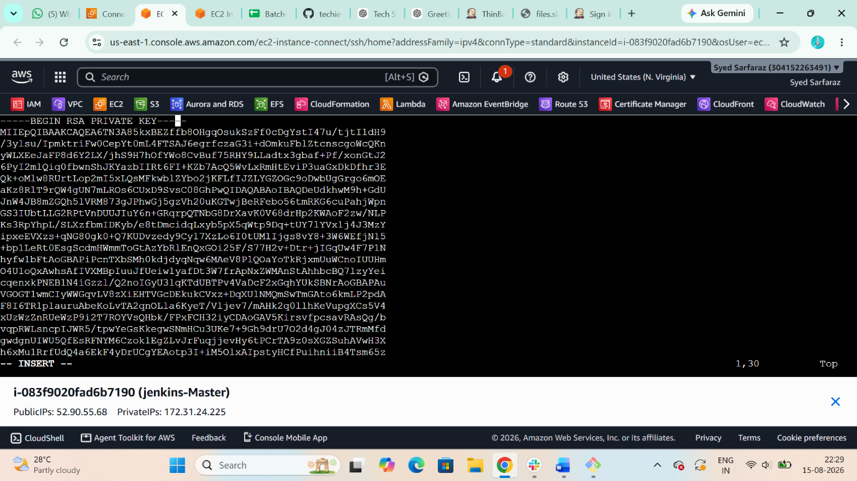
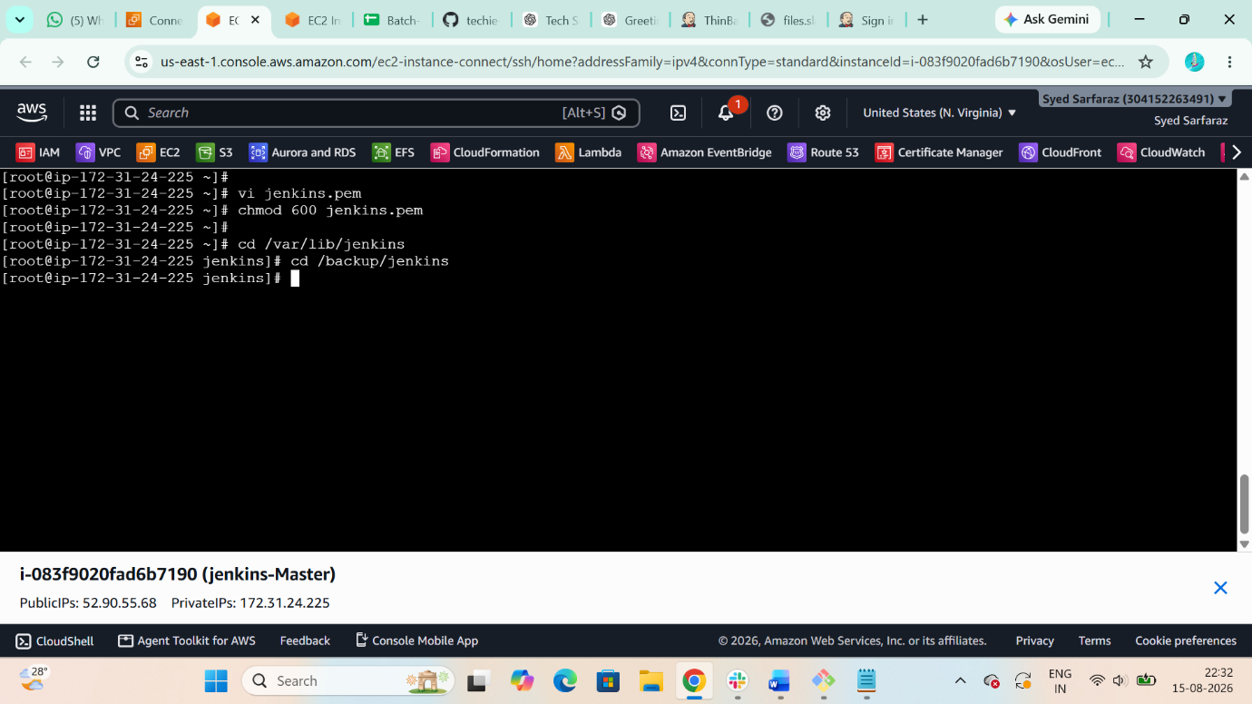

this below command should run in old machine :
vi jenkins.pem
chmod 600 jek.pem
scp -i jek.pem /backup/jenkins/jenkins_backup_2026-08-15_15-48-49.tar.gz
ec2-user@18.208.157.10:/tmp/
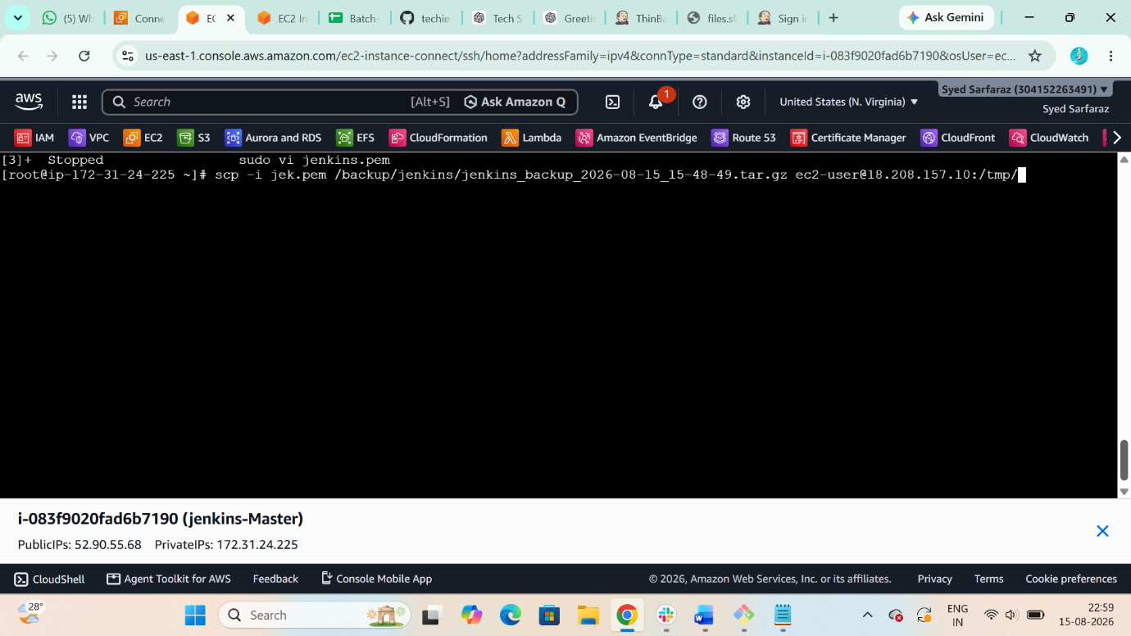

after creating copy verify in THIS COMMAND IS NEW MACHINE
IT WILL SHOW TAR FILE WE COPIED WITH OTHER MACHINE
$ cd /tmp
$ ll
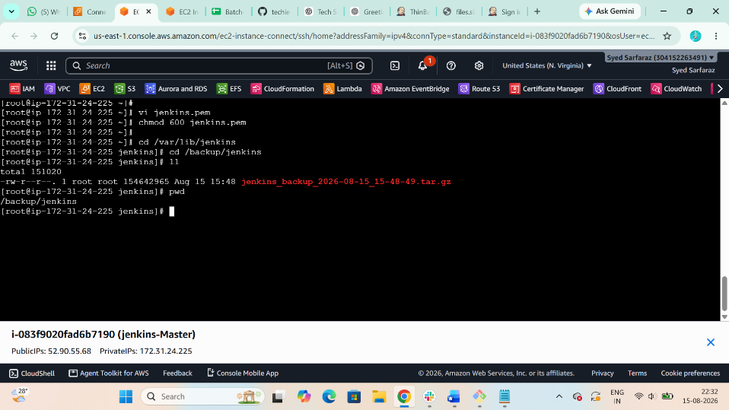
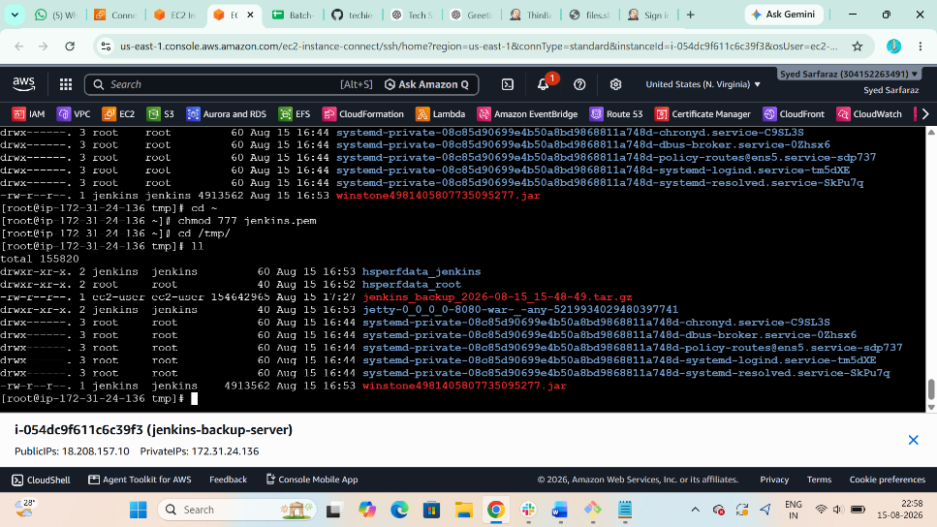

$ sudo systemctl stop jenkins
$ sudo systemctl status Jenkins
$ sudo mv /var/lib/jenkins /var/lib/jenkins-original
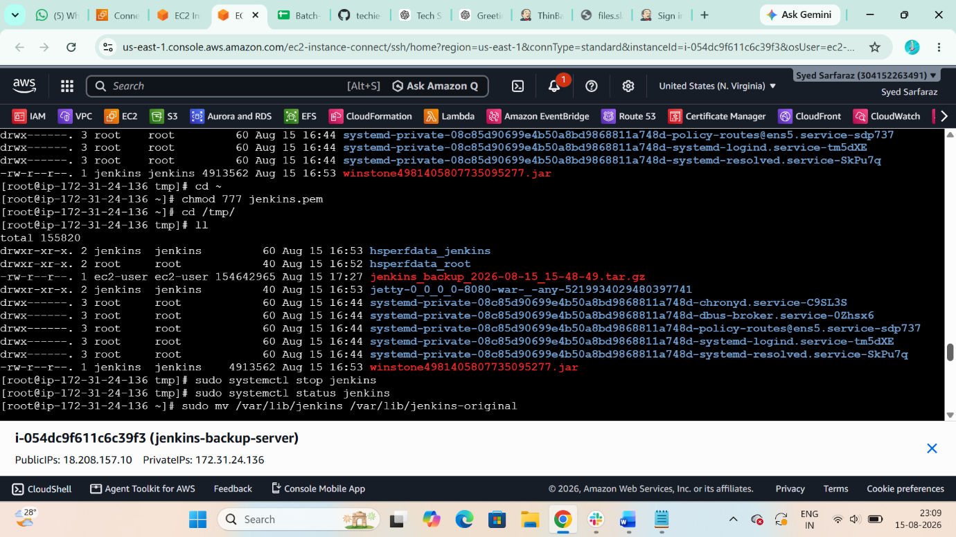
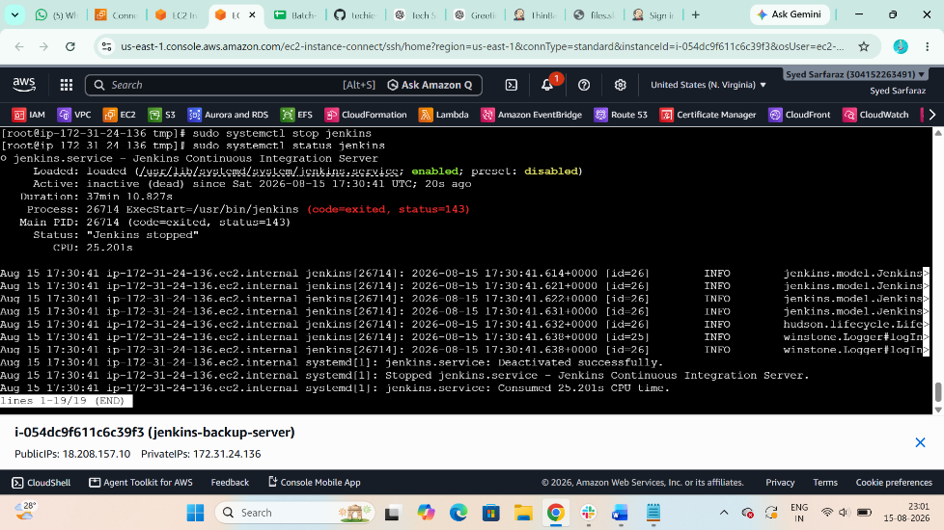
$ sudo mkdir -p /var/lib/Jenkins
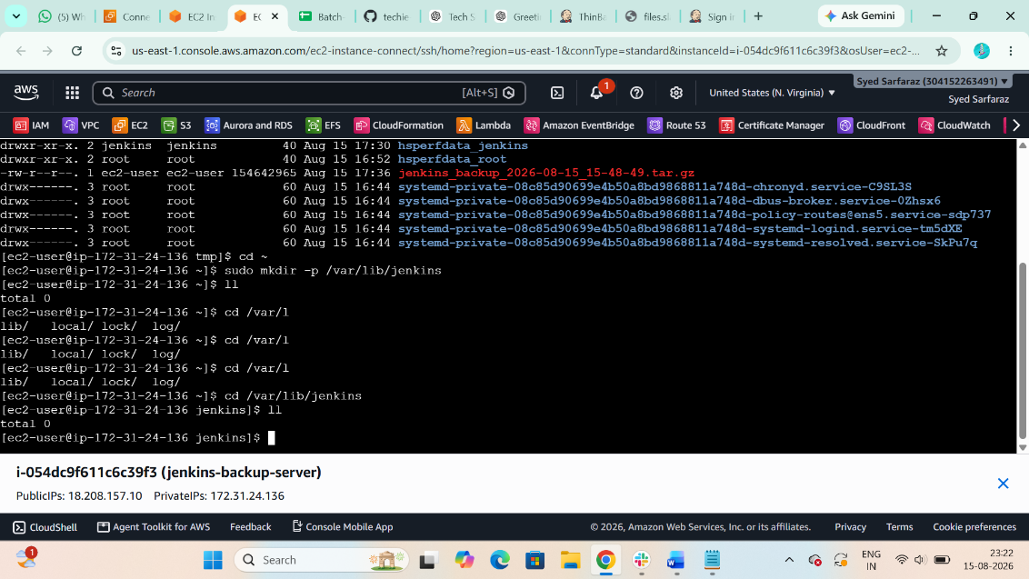
$ sudo tar -xzf /tmp/jenkins_backup_2026-08-14_15-50-22.tar.gz \
-C /var/lib/Jenkins
$ sudo chown -R jenkins:jenkins /var/lib/Jenkins
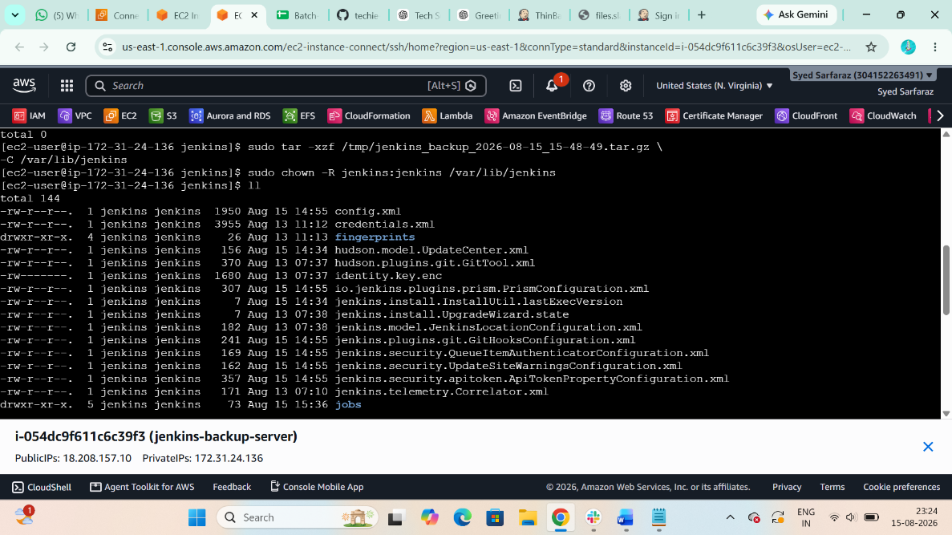
$ sudo chmod 755 /var/lib/Jenkins
$ sudo systemctl start jenkins
$ sudo systemctl status Jenkins
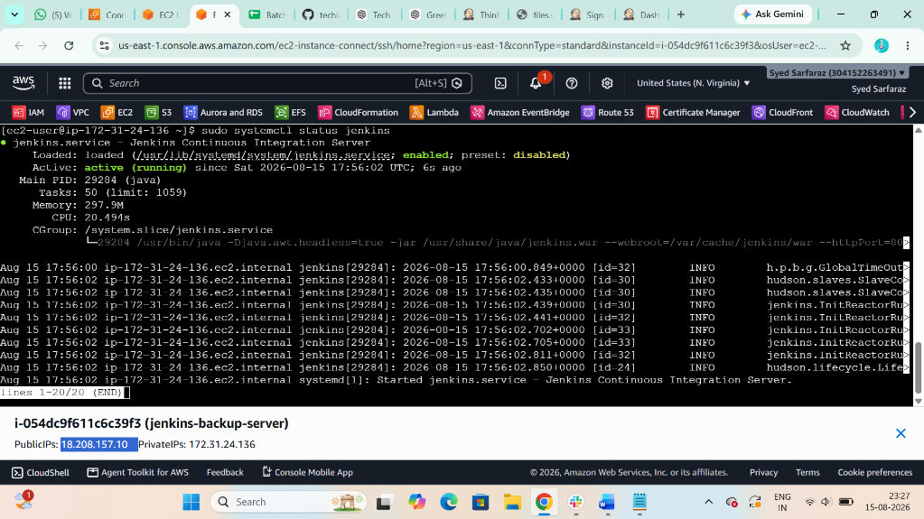

Now Back-up is completed we get our old Jenkins data in new Jenkins server
